Appendix B – Identifying Bacteria

Bacteria identification is accomplished in a number of ways. Two common tools microbiologists use to identify unknown bacteria include dichotomous key and biochemical tests. The dichotomous key is useful when a microbiologist only needs to know which group an unknown microbe belongs to on a general level. When a microbiologist needs to identify a specific bacterium, biochemical tests are used.

PART ONE: GENERAL BACTERIA IDENTIFICATION
Review the dichotomous key in Figure A, the bacterial shapes in Figure B, and the Gram stain information below. You will use all three to determine to which major group unknown bacteria belong.

Figure A: A dichotomous key for classifying major groups of bacteria.
[Figure 9.4 in Microbiology text]
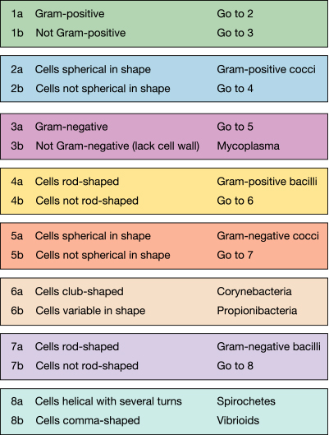

Figure B: The most common bacterial shapes.
[Figure 4.1 in Microbiology text]
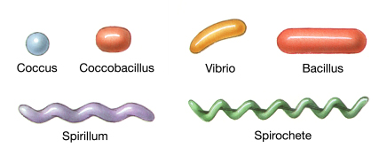
Shape Types:

Comma, or Club-shaped, rods = Vibrio
Rods = Coccobacillus, Bacillus
Spherical = Coccus
Spiral or Helical = Spirillium, Spirochete

Gram Stain Results:

Purple = Gram positive
Red = Gram negative
Neither purple nor red = No cell wall (neither Gram positive nor Gram negative)

Review Figure C on the following page. Use Figure C to identify the type of arrangement displayed by the unknown bacteria. Read through the Sample Identification on the following page for an example of how to identify bacterial groups and arrangements using Figures A, B, C, and the Gram stain results.
Figure C: Arrangement of Bacteria
Rods and Clubs
Single  Strepto-  Cording  Snapping  Palisades  Chinese Letters | 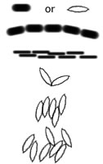
Cocci
Single  Diplo-  Tetrad  Sarcinae  Staphylo-  Strepto- | 
Sample Identification

After performing a Gram stain, you observe the following under a microscope:

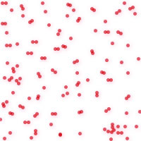
(Cells are stained red.)

- Begin with item 1 on the dichotomous key (Figure A). Because the organisms are red, they are not Gram-positive. According to the key, continue to item 3.
- Because the organism is red (not clear or another color), it is indeed Gram-negative according to item 3. The key directs you to item 5.
- Consider the shape of individual cells for item 5. According to Figure B, the shape type is closest to spherical. (Note: spherical is circular.)
- The bacteria belong to the Gram-negative cocci group.
- Now use Figure C to describe arrangement of bacteria. (The bacteria are not rod- or club-shaped, so focus on the cocci arrangements.) Identify the arrangement that is most prominent.
- The bacteria are arranged in a diplo- fashion.
- Enter the group and arrangement in the table.

Application

Use Figures A, B, C, and Gram stain results to identify group and arrangement of bacteria. Continue to Part Two after completing the table.

View from Microscope | Group of Bacteria | Arrangement
(stained red) | Gram-negative cocci | Diplo-

(stained purple)

(stained purple)

(stained red)

(stained red)

(stained purple)

(stained purple)

PART TWO: CAse study scenario: identify specific bacteria through biochemical testing
To gain an understanding of the processes involved with identifying bacteria through biochemical tests, access Chapter 6 of the text in WileyPlus located on the Week One course page. Once in WileyPlus (Chapter 6), select the “Bacterial Identification by API” link located under the heading, Take Another Look. Once selected, review the information and watch the Flash-animated movie (animation) located within this link. Then, review the following scenario and answer the questions that follow.
Case Study
A recent outbreak of food poisoning has occurred in a community. One possible source of contamination may be the produce that is grown and distributed locally at a farmer’s market. A test sample of some of the produce revealed evidence of bacterial contamination. The bacteria sample was tested in a microbiology lab and showed the results that follow. The laboratory also performed a Gram stain of the isolated bacteria and ran a number of biochemical tests to aid identification. The biochemical tests were assayed using the Analytical Profile Index (API) 20E system for identification of Enterobacteriaceae and other gram-negative bacteria.
Figure 1. Microbiology laboratory results – Unknown bacteria present on produce (API Results)
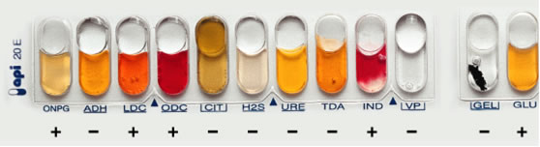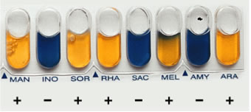
Figure 2. API Results of Unknown Bacteria in Text Format
Gram stain:  Gram-negative | ONPG | ADH | LDC | ODC | CIT | H₂S | URE | TDA | IND | VP | GEL | GLU
Bacteria: Unknown | + | - | + | + | - | - | - | - | + | - | - | +

MAN | INO | SOR | RHA | SAC | MEL | AMY | ARA
+ | - | + | + | - | + | - | +
Based on Gram stain results and the knowledge that this bacterium caused food poisoning, the laboratory is able to narrow down the possibilities to three bacterial strains. Figure 3 shows the API results:
Figure 3. API Results of Known Bacterial Strains in Text Format
Gram stain:  Gram-negative | ONPG | ADH | LDC | ODC | CIT | H₂S | URE | TDA | IND | VP | GEL | GLU
Bacteria: Salmonella | - | - | + | - | - | - | - | - | - | - | - | +

MAN | INO | SOR | RHA | SAC | MEL | AMY | ARA
+ | - | + | - | - | + | - | -

Gram stain:  Gram-negative | ONPG | ADH | LDC | ODC | CIT | H₂S | URE | TDA | IND | VP | GEL | GLU
Bacteria: Shigella | - | - | - | - | - | - | - | - | - | - | - | +

MAN | INO | SOR | RHA | SAC | MEL | AMY | ARA
- | - | - | - | - | - | - | -

Gram stain:  Gram-negative | ONPG | ADH | LDC | ODC | CIT | H₂S | URE | TDA | IND | VP | GEL | GLU
Bacteria: E. coli | + | - | + | + | - | - | - | - | + | - | - | +

MAN | INO | SOR | RHA | SAC | MEL | AMY | ARA
+ | - | + | + | - | + | - | +

Application
Compare the API biochemical test results in Figure 2 (unknown bacteria from produce) with API test results in Figure 3 (known bacterial strains identified in the gray boxes on the left). The bacterial strain in Figure 3 that matches Figure 2 will identify the bacterial strain causing illness. Based upon your observations, which of the bacteria in Figure 3 is the most likely cause of the food poisoning outbreak?

